PAPER: How to use score-based diffusion in earth system science: A satellite nowcasting example, https://arxiv.org/pdf/2505.10432 (Dec, 2025)

Brief Description:
Overview:
Introduces Score-based diffusion models as a superior alternative to traditional ML for satellite-based cloud nowcasting.
Training:
- Three specific architectures: Diff, CorrDiff, and LDM.
- Found that the CorrDiff approach performs best by refining a preliminary conventional U-Net prediction, preserving high-resolution images longer into the forecast.
- The model is guided by a Score Function, pointing the way to a more realistic image.
Conclusion:
- Beyond improving visual clarity, these models successfully simulate complex atmospheric processes like convective initiation and cloud decay.
- Provided a practical framework to help earth scientists implement these advanced generative techniques in their own environmental research.

Explanation:
Forecasting with AI:
We don't want just any weather pattern. We want the specific weather pattern that's gonna happen 10mins to 3 hours from now. We use Conditioning for this.
Instead of just giving the model a noisy image and telling it to clean it up, we give it that noisy image plus a little hint. And in this case, that hint is the real satellite images from the last hour or so.
- Now it won’t just generate like another satellite image. Instead, it uses logic to generate a realistic forecast. Past is conditioning the future.
Diffusion Model Versions:
- DIFF: Standard Score-based Diffusion Model approach (Karras et al. 2022)
- CorrDIFF: Residual Correction Diffusion Model (Mardani et al. 2025; Pathak et al. 2024)
Lets a conventional AI (pre-trained U-Net) takes a first quick shot at the forecast, which ends up a bit blurry, then it uses the diffusion model to come in and correct that guess, adding all the realistic sharp details. Turned out to be a top performer.
- LDM (Latent Diffusion Model): (Rombach et al. 2022; Leinonen et al. 2023).
It is super fast and efficient. Running the whole diffusion process on big, high-resolution image over and over again takes a ton of computing power. So the LDM uses a separate AI (pre-trained Variational Autoencoder) to first compress the big image into a much smaller, data-packed version of itself (Dimensionality reduction) which is called the Latent Space. It then runs the entire diffusion process (from noise to clean image) in this space. At the end, it uses another AI to get the original dimensions of the image.

SCORE-BASED DIFFUSION MODEL:
Score-based diffusion is a distribution-to-distribution transformation.
What is Distribution?
Imagine huge pile of satellite images. Not every plausible arrangement of pixels is a satellite image. It could be just a static noise image. Real satellite images have structure: smooth cloud edges, hurricane spirals, coherent temperature gradients.
A probability distribution is the mathematical object that captures "which images (pixel arrangements) are plausible and which aren't."
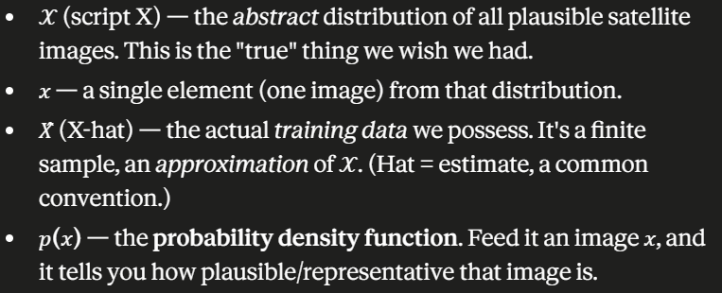
P(x) is a likelihood. In theory, any combination of pixel values could come out of the satellite images dataset but some combinations are far more likely than others.

Core Problem:
“We have neither an explicit formula for 𝑝(𝑥) nor a way to draw new samples from 𝒳.”
We want new satellite images, but we have no equation for what makes an image plausible. But there’s one distribution we understand perfectly.
“We do know how to sample from a Gaussian distribution 𝒩(μ, σ) (the bell curve), which the paper calls the "known distribution."”
We can generate gaussian samples trivially. It is essentially a White Noise (Pure Static).
Idea: “If I can find a mapping 𝑝(𝑥, σ) between the easy Gaussian noise distribution and the hard image distribution 𝒳, then I can sample noise (easy!) and transform it into a plausible image (the thing I wanted).”
This is the “distribution-to-distribution transformation”. Noise distribution → image distribution
Forward and Backward Processes:
How do we build a bridge between noise and images? The Mapping between distributions?
𝒳 is renamed 𝒳₀ : the subscript 0 means "noise level zero," i.e., clean images.
Then for any amount of noise σ, we have 𝒳_σ, the distribution of images that have had a quantity of white noise added
Forward process (No learning needed): Start with a clean training image from 𝑋̂ and repeatedly add Gaussian noise until nothing but noise is left. At the top, 𝒳_σmax ≈ 𝒩(μ, σmax) : pure Gaussian. This is easy and efficient; you can even jump directly from a clean image to a fully-noised one in a single step because adding Gaussian noise has nice mathematical shortcuts.
Backward process (Learning is needed). Start with pure noise at the top and iteratively remove the noise, step by step, until a clean, plausible image emerges at the bottom. The paper's exact phrasing of the trick: the backward process iteratively removes noise while guiding each pixel's value so the modified image becomes representative of 𝒳. We can't do this analytically, so we train a neural network to do it.

The Score Function (The guiding part in the Backward process):
You're at some noisy point and you want to step toward "more plausible." Which direction is that?
At each iteration (of removing the noise), we want to move the sample 𝑥 toward where it becomes more likely under the data, 𝑝(𝑥, σ) at the current noise level. "Move toward higher likelihood" is, in calculus, the gradient of the likelihood. And because probabilities are easier to handle in log-space, we use the gradient of the log-likelihood. This object has a name:
The score function is defined as ∇ₓ log 𝑝(𝑥, σ).
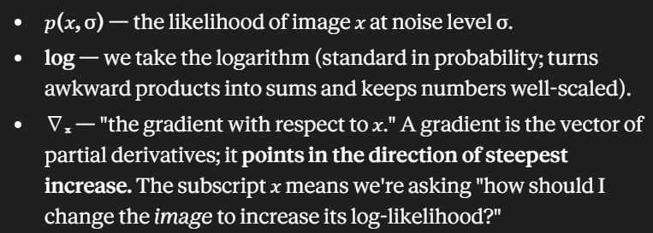
The score function is an arrow, sitting at every point in image-space, pointing toward more plausible images.

Ordinary Differential Equation (ODE):
Now we make "follow the arrows downhill in noise" into a precise mathematical statement.
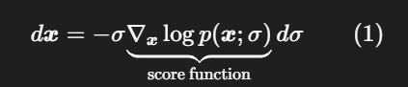
An equation of the form "d𝑥 = (something) · dσ" says: if I change the noise level by a small amount dσ, here is how much the image 𝑥 should change (d𝑥) in response.
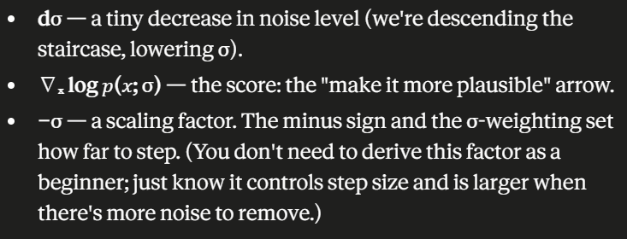
ODE Says:
At each small reduction of noise, nudge the image along the score direction, scaled appropriately. Repeat from pure noise down to zero noise, and you trace a path that lands on a real image.

This equation has a practical flaw. To follow the arrows, you need the score ∇ₓ log 𝑝(𝑥; σ) at every point. But we never had the formula for 𝑝(𝑥) in the first place. So how can we compute the gradient of its log?
This is the clever turn that makes the whole method work, and it comes from Karras et al. (2022), whom this paper builds on.
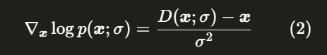
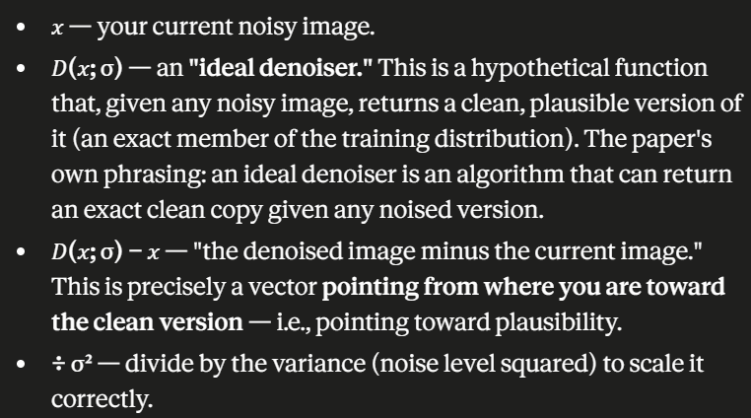
The score (the abstract "toward plausibility" arrow) is just (denoised image − current image), suitably scaled. Knowing which way to make an image more plausible is the same thing as knowing how to denoise it.

TRAINING A NEURAL NETWORK:
How we build an approximation of the Denoiser with a Neural Network?
- Basic Loss
- Weighting refinement
- Reparameterization
We replace the idealized 𝐷 with a learnable network we'll call 𝐷_θ, the subscript θ (theta) stands for "the network's parameters/weights," the millions of numbers we tune during training.
LOSS:
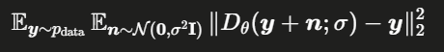
- 𝑦 — a clean, original (non-noised) training image. The paper's variable for "the truth we want back."
- 𝑛 — a chunk of Gaussian noise, drawn from 𝒩(𝟎, σ²𝐈). Read that as: noise centered at zero (mean 𝟎), with variance σ² applied independently to every pixel. The 𝐈 is the identity matrix, and its dimension is just "however many pixels are in the image" — it's the formal way of saying "add independent noise to each pixel, no correlations between them."
- 𝑦 + 𝑛 — the clean image plus noise = a noisy image (which in 2c we called 𝑥).
- 𝐷_θ(𝑦 + 𝑛; σ) — the network's attempt to clean it back up. We also tell it the noise level σ so it knows how hard the corruption was.
- 𝐷_θ(𝑦 + 𝑛; σ) − 𝑦 — the network's output minus the true clean image = the error.
- ‖ … ‖₂² — the squared L2 norm, which is just "sum of squared differences across all pixels." This is the familiar Mean Squared Error (MSE). Squaring makes all errors positive and punishes big mistakes harder.
- 𝔼 (the two of them) — expectation, meaning "average over."
Double Expectation: two sources of randomness we average over
- 𝔼 over 𝑛 — average across all the random noise draws and noise levels σ. The network must handle a faint speckle (σ = 0.5) and a near-total whiteout (σ = 5) alike.
- 𝔼 over 𝑦 ∼ p_data — average across all the different training images. The network must denoise hurricanes, clear skies, cloud bands, everything.
Because you're sampling over both images and noise levels, diffusion training typically needs a bigger batch than a plain network, and you need enough variety in each batch to estimate that average well. A batch that only had clear-sky images at low noise would teach the network almost nothing about the rest of the space.

Weighting Refinement: (Caring more about low noise)
In practice the loss is scaled by 1/σ, weighting it more heavily at low noise levels.
“At small σ (little noise), the network should be close to the true answer, so we weight the loss more heavily there to encourage it to nail those cases.” (where the real image takes shape)
One Training Step:
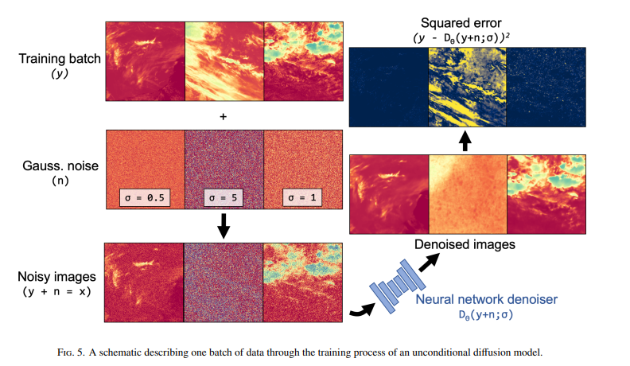
- Select a batch of clean satellite images
- For each image, draw a random noise level σ from a user-defined distribution, and generate Gaussian noise 𝑛 at that level
- Add it to get noisy images (𝑦 + 𝑛 = 𝑥).
- Feed those into the network 𝐷_θ to get its denoised guesses.
- Compute the MSE between the guesses and the true clean images
- Backpropagate that error through the network to nudge its weights.
- Repeat until the loss converges.
NOTE: The choice of architecture is arbitrary: U-Nets, vision transformers, and graph neural networks have all worked as denoisers.

REPARAMETERIZATION:
Karras et al. (2022), whom this paper follows, found that asking the network to output the clean image directly is numerically awkward. So they wrap the actual network, now called 𝐹_θ, inside a set of scalings:
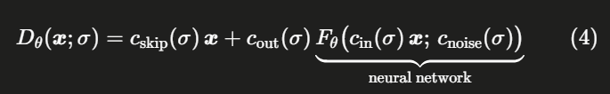
𝐹_θ is the raw neural network; 𝐷_θ is the denoiser we actually use.
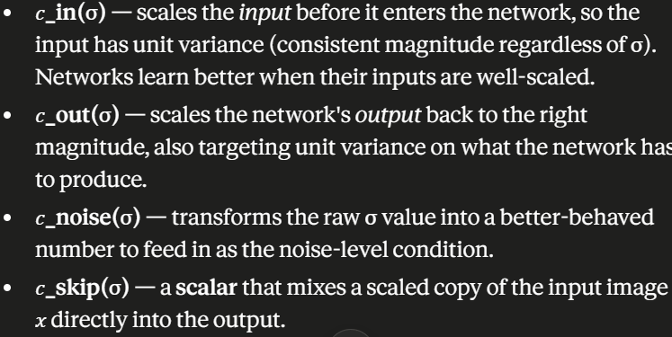
Scaling is required so that errors in the network are not amplified. The paper gives the exact scaling formulas.
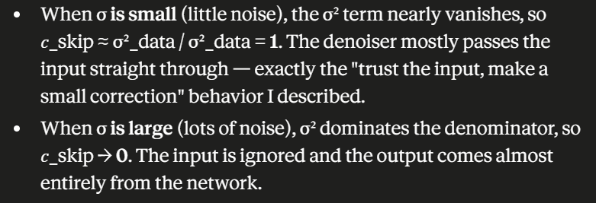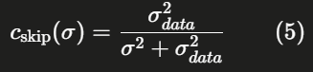
Intuition: at low noise the image is already almost clean, so the smart move is to mostly keep the input (large 𝑐_skip) and let the network make only a small correction, that way a wobbly network prediction can't do much damage. At high noise the input is nearly useless, so you lean harder on the network's output instead.

NOTE: The other three (𝑐_in, 𝑐_out, 𝑐_noise) handle the variance-normalization and noise-conditioning. The paper notes these come from Appendix B.6 of Karras et al. (2022), and adds a practically useful endorsement: these functions worked well for their satellite nowcasting task and are likely a good starting point for other Earth and environmental science problems too.

Adding Controlled Randomness:
To generate new images, we sample noise down to zero (e.g starting point: 80). We’ll get a traced path trajectory to a real image guided by the denoiser neural network.
These trajectories turned out to be nearlys traight and fully deterministic. Because the distribution 𝑝(𝑥; σ) is fixed, each trajectory is completely determined by where it started. Same seed → same image, every time. That's the defining property of the ODE version.
If every trajectory is locked to its seed, you get less variety across the images you generate.
So the paper introduces a twist: inject a little extra random noise during the descent.
During descent, we add a small random nudge randomly to the score direction back toward the higher noise. This converts the deterministic ODE into a stochastic differential equation (SDE). "stochastic" just means "with randomness baked in."
The paper's term for the benefit is that it enhances ensemble image diversity across samples. You get a richer spread of plausible outputs from the same model. This is especially valuable in a forecasting context, where you often want an ensemble of possible futures rather than one rigid answer
The two knobs that control this, from the Karras et al. (2022) framework and code:
- S_churn — the scale of the noise added back in (how much randomness to inject overall).
- S_noise — the amount of noise in each injection.
Set S_churn = 0 and you're back to the pure deterministic ODE. Turn it up (S_churn > 0) and you get the wandering stochastic paths. It's a dial between reproducibility and diversity.

ADDING A CONDITION:
“Everything so far was unconditional. But most Earth and Atmospheric Science tasks need conditional generation. Their task: generate a specific GOES IR image — the image 10 minutes from now.”
Solution is:
“Include the condition, the past 2 satellite images, as additional channels to the input. That is, concatenate the condition onto the noisy image before handing it to the denoiser U-Net.”
Before, we could conjure plausible satellite images from noise, but couldn't tell which image we wanted. By feeding in the two most recent frames as extra input channels, the same denoising-descent process now produces the specific image that follows from the current weather, which is precisely a 10-minute nowcast.

‘Channels’ and ‘Concatenate’ terms:
- A color image has 3 channels stacked together: Red, Green, Blue (3 layers deep, same spatial grid)
- The network sees all three at once.
- We add two extra layers of satellite frames.
- So instead of handing the network just the noisy image to denoise, you hand it a stack: [noisy image | past frame 1 | past frame 2].
The network now sees both "the thing I'm cleaning up" and "what just happened," and it can use the recent history to inform its denoising.
Evidence: “The conditional model yields very low errors, while the unconditional model has very large errors, especially at the largest noise level (σ = 5).”
- The score function becomes ∇ₓ log 𝑝(𝑥 | 𝐜; σ)
- The denoiser becomes 𝐷_θ(𝑥 | 𝐜; σ)
Before, we asked "how plausible is this image?" Now we ask "how plausible is this image given what just happened?"
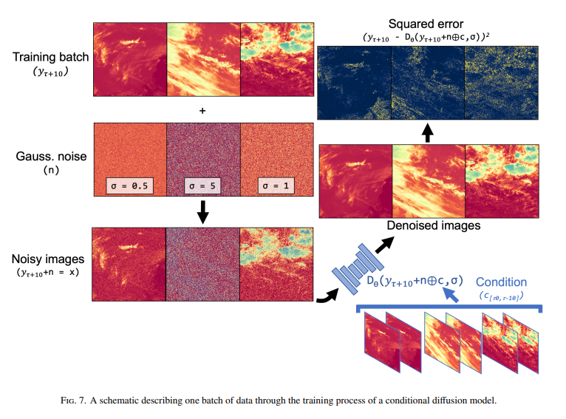
Alternative: Guided Diffusion and Baye’s rule
The paper is honest that concatenating channels isn't the only way to condition, and it sketches a more sophisticated alternative used by several other groups. They split the conditional score into two pieces using Bayes' rule
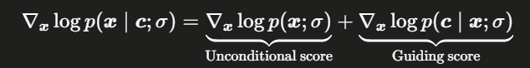
Bayes' rule says 𝑝(𝑥 | 𝐜) ∝ 𝑝(𝑥) · 𝑝(𝐜 | 𝑥). Take the log and a product becomes a sum: log 𝑝(𝑥 | 𝐜) = log 𝑝(𝑥) + log 𝑝(𝐜 | 𝑥) + constant. Then take the gradient ∇ₓ, and the constant drops out (its derivative is zero), leaving exactly the above Equation.
- The unconditional score ∇ₓ log 𝑝(𝑥; σ): the same "toward any plausible image" arrow
- The guiding score ∇ₓ log 𝑝(𝐜 | 𝑥; σ): a correction that asks "given a candidate image 𝑥, how well does it explain the observed condition 𝐜?" and nudges generation toward images consistent with 𝐜.
This approach is known as GUIDED DIFFUSION. Observations guide the generation.
This is a future research!!

TRAINING DIFFUSION MODELS:
- The first diffusion model, named Diff follows the Karras et al. (2022) framework, where the denoiser is denoising the 10 min forecast.
- The second diffusion model, named CorrDiff, follows the approach from Mardani et al. (2025) and Pathak et al. (2024). It uses the pre-trained U-Net of the baseline model to get an initial, potentially blurry, prediction of the 10 min forecast. Then it trains a denoiser to improve the forecast of the plain U-Net. This predicts the difference between the plain U-Net estimate and the truth.
For all Diffusion models, denoisers are trained for:
- Epochs: 1000
- Batch Size: 45
- two-batch gradient accumulation (i.e., effective batch size of 90)
- Networks see more than 35 million images
- Validation test set is of 1000 images
These models take about 5 days of training on GH-200 with 98% average GPU utilization
- To reduce the training time, LDMs were explored.
  - Used a pre-trained variational autoencoder (VAE) to compress 256x256 image to 64x64.
  - Due to the channel size going, the compression factor is only 4.
  - The choice of VAE is dependent on the smallest reconstruction loss on the dataset.
  - Used the compressed data to train the denoiser for diffusion in this latent space.
  - Resulted in a 5 times speed-up in training, where the latent model completed training for 1,000 epochs in about 1 day.
Variational AutoEncoders:
LDMs require the use of VAEs for compressing meteorological imagery. Given there are many pre-trained autoencoders on pics of cats, dogs, people, etc.
- In general, most of the VAEs have poor reconsturctions. Note that you gotta test a few VAEs if you intend to go this direction.
Generation Hyperparameter details and Ensembles:
Diffusion machine learning tasks are split into training the denoiser and generation. With this split come a few additional hyperparameters solely linked to the generation procedure. These are centered on:
- how many denoising steps to take (num steps);
- the maximum noise level to start from (sigma max);
- the spacing of the steps (rho);
- the amount of stochastic noise injected into the denoising process (S_churn);
- the scale of noise added back in (S_noise)
Just like training hyperparameters, a hyperparameter search would ideally be done for all diffusion models trained. But because of training time, paper resorted to doing Sparse hyperparameter search on LDM and assumed it for other models.

“More specifically, we perform a gridsearch of four of the above hyperparameters for the latent model and then choose the best joint performance of root mean squared error and the spread–skill ratio on the 1,000 example validation (i.e., use 10 different noisy images to start with the same two condition images)”.
Spread-Skill ratio is a metric for ensemble skill. More information on this is there in section 4d (pg 12)
Autoregression:
“All machine learning forecast methods trained here follow the structure of many of the data-driven weather prediction models and optical flow techniques where two images (𝜏0, 𝜏−10) are used to forecast a single time step (𝜏+10)”
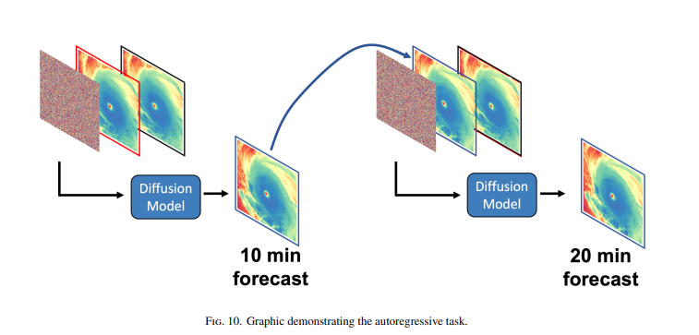
Metrics:
These are the common pixelwise metrics to get a general quantification of the forecast performance:
- Mean error
- Mean Absolute Error
- Root Mean Square Error

Testing (South America off coast):
Skies had low-level clouds, high-level wispy clouds, and even brand new storms starting to bubble up.
CorrDIFF predicted the forecast with cloud textures, the sharp edges, and incredible clarity. But it got a huge compute power. With LDMs, this can be reduced.
For each approach, here are good performance (Worked) and under performance (Under) factors:
Plain U-Net
- Worked: advects clouds initially; comparable to all methods at the single 10-min forecast (Fig. 12 row 1).
- Under: goes blurry by 1 hr: cirrus soft/diffuse, stratocumulus deck too uniform in texture; worsens at 2–3 hr (cirrus missing, artifacts in NW corner + SE land).
- Under: warm bias growing with lead time, plus a cold bias where the stratocumulus deck doesn't erode fast enough along the coast (Fig. 13 row 1).
- Verdict: usefulness limited after ~1 hr.
Diff (plain diffusion, Karras et al. 2022)
- Worked: scene loosely evolves like observations (stratocumulus recedes west and breaks up).
- Worked: initiated convection close to where observed, despite only ~20 min of input data — and stays realistic (not blurry) out to 3 hr.
- Under: overall scene a bit noisy → suggests suboptimal generation hyperparameters.
- Under: overall warm bias (Fig. 13 row 3); ensemble members disagree on convection location (ensemble mean smoother, loses the single-member cold clouds).
CorrDiff (uses plain U-Net forecast as extra input)
- Worked: considerably less noisy/clearer than Diff (better hyperparameters and/or U-Net gives a good initial guess so diffusion handles small-scale detail; Mardani et al. 2025. U-Net reduces task variance).
- Worked: resolves the westward stratocumulus retreat much better, with a few breaks in the deck; convects like Diff.
- Under: convection appears further NE than observed; cirrus streamer not captured beyond ~1 hr (too tenuous).
- Under: overcorrects the U-Net input into a cold bias (Fig. 13 row 4).
LDM (latent diffusion model)
- Worked: first-hour evolution similar to the other diffusion models; can evolve clouds and initiate convection.
- Worked: fastest model, runs 5–10× faster.
- Under: after 1 hr, strong cold bias at image edges (Fig. 13 row 5), suspected from non-optimal autoencoder encoding (odd cold/hot edge pixels, Fig. 9b/9d).
- Under: surface-warming evolution looks off vs. other diffusion models and observations, clear speed-vs-accuracy tradeoff.
Also, Look at Spectral Analysis for each model if you decided to do that!!

DESIGN CHOICES:
- “We chose the overall framework of score-based diffusion models over DDPMs because they are significantly faster without presenting any disadvantages”
- Underlying architecture have an affect on the timeliness of the model. Turns out this architecture, while skillful, had many parameters and some attention layers that made training and inference times considerably large (5 days to train; 10 minutes to run a 3 hour forecast for 10 ensemble members).
  - An alternative route would have been to investigate simpler underlying architectures that are faster (e.g., less parameters, careful placement of attention layers), or explore other community provided and optimized networks like NVIDIA’s PhysicsNeMo which is used in Mardani et al. (2025) and Pathak et al. (2024).
- An even bigger question for any specific application is whether diffusion models are worth the effort, including more complex code base and large computational costs for both training and inference. For example, ECMWF explored two options to extend AIFS - their AI-based global weather forecasting model (Lang et al. 2024a) - to provide probabilistic forecasts: (1) integrating diffusion models (Chantry et al. 2025), or (2) utilizing the Continuous Ranked Probability Score (CRPS) (Lang et al. 2024b) as a loss function to be used with a simpler neural network. After trying both approaches the CRPS route was chosen for first operationalization.
  - Similarly, Google’s operational weather forecast models have seen a shift from Diffusion with their GenCast model (Price et al. 2025) to a similar CRPS loss with their FGN model (Alet et al. 2025), where the FGN model is now in operations.
  - Following these two efforts, other global weather models have also used CRPS losses to get ensemble forecasting.
  - there are many researching how to speed up diffusion (e.g., Xu et al. 2025).
- Another limitation of this work was the lack of comparison of the trained machine learning methods here to other methods of forecasting satellite brightness temperatures. Future work would ideally include forecasts from both traditional numerical weather prediction (e.g., Griffin et al. 2017, 2024) and optical flow (e.g., Shakya and Kumar 2019)

Future Work:
- “We attempted a latent CorrDiff model by training the corresponding U-Net model entirely in the latent space, but the U-Net predictions in the latent space were poor on their own and we decided to not pursue it further for this paper.”
- “Tuning the pre-trained VAE or training a VAE from scratch on satellite data specifically are both topics of future research.”
- “Hyperparameter search” on Diffusion model for generation procedure

